**Requirement Document for Turkey Tariff Extractor**

Source Link: <http://www.tariff-tr.com/>

Go to above source link you will get the following screen below and click on login.

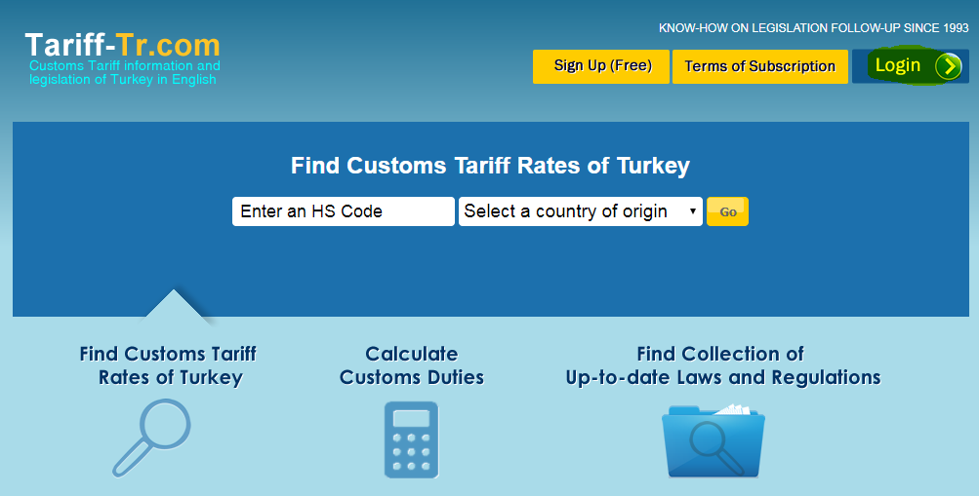

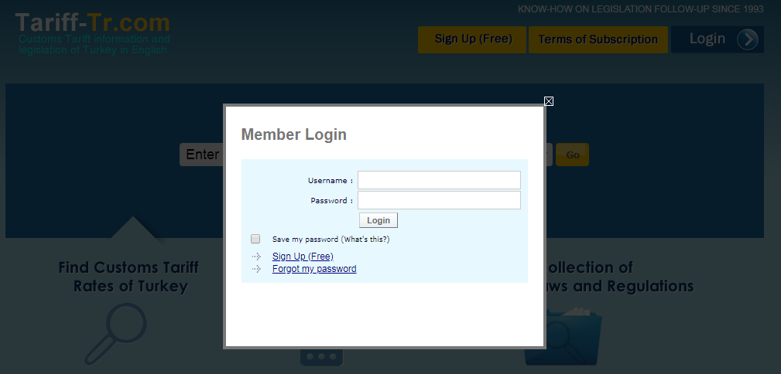

Once click on Login will get the following screen (Refer screenshot above^) and need to enter Username & Password as mentioned below:

Username : pragatishree

Password : 1098

Once login using above details will get following screen below, need to click on Tariff Search and enter 4 digit HSN “0101” in HS Code text box and click on “Tariff Rates (Detailed)” button (Refer screenshot below)

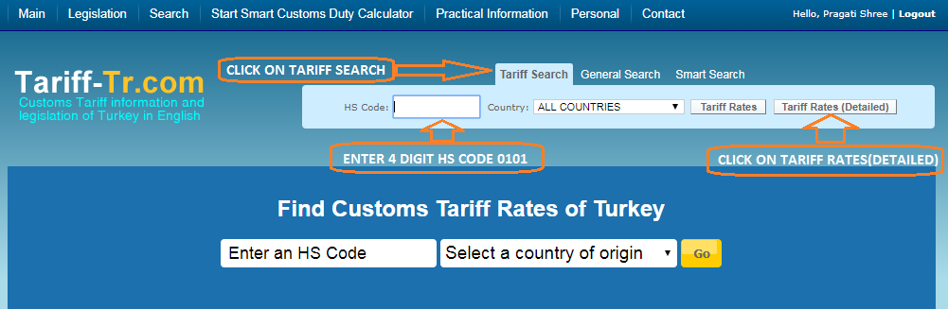

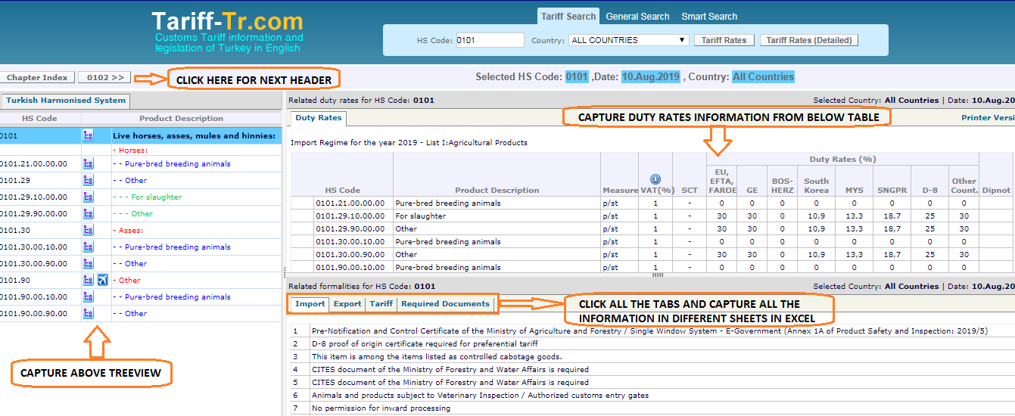

In the above screenshot need to capture treeview, duty rates information

**Note:** required to capture header information to all the headers due to headers of the table may change for header to header

Also need to click on Import, Export, Tariff & Required Document tabs and capture all the information in separate excel sheets and mention tab names on it.

Refer sample file below:

Data would be extract in below format

